CE 6303.001

HW2 Report

**Luke Allen** NetID: laa170930

**Yu Feng** NetID: yxf160330

09/06/2021

# Problem Description:

The problem that was given was to follow the design compiler tutorial and provide the critical path, netlist, timing report, and output waveform of the two bit adder behavioral code created in Homework 1.

# Schematic:

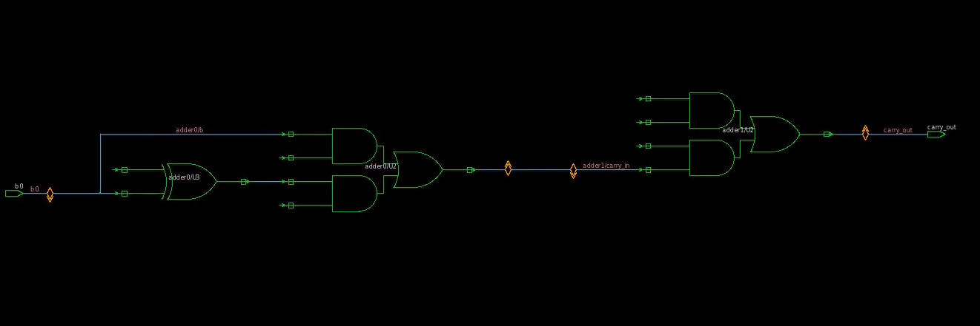

# Netlist:

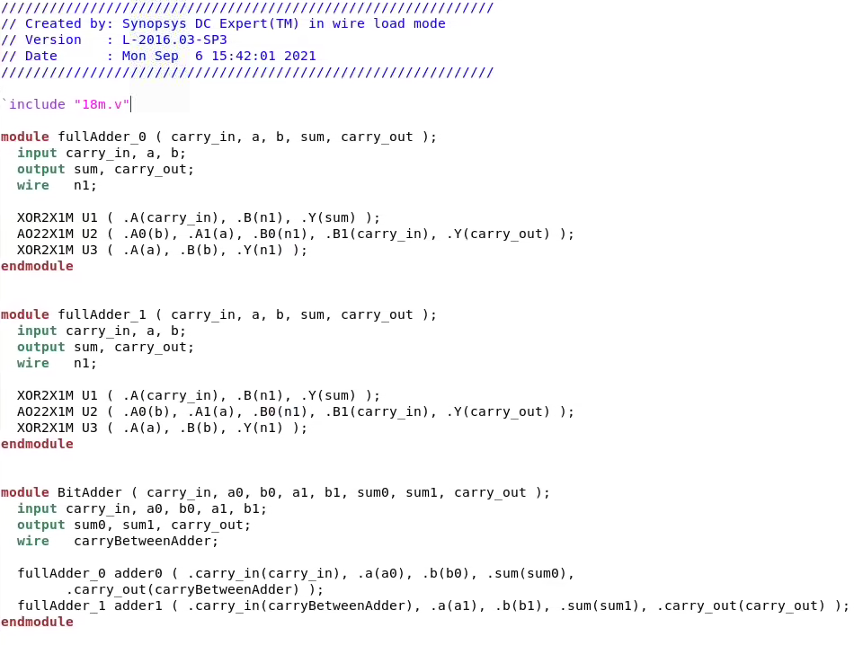

# Timing Report:

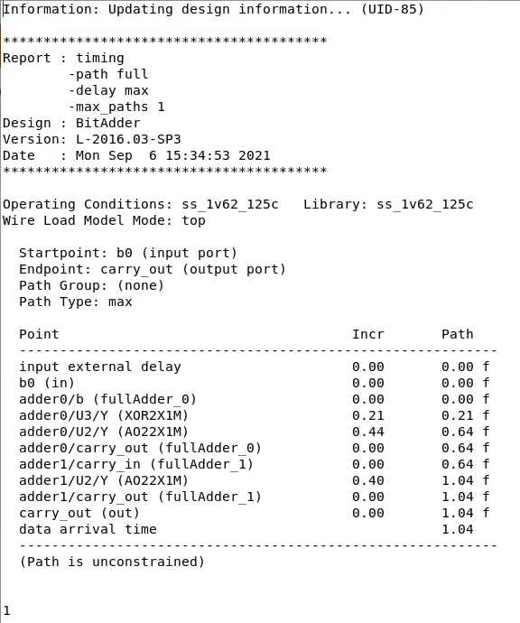

# Waveform:

